A wireless sensor network to survey rockfall protective structures
Richard Koschuch², Tobias Schöffl^{1,2}, Suzana Svetlicic³, Phillipp Jocham⁴,
¹University of Natural Resources and Life Sciences, Institute of Mountain Risk Engineering, Vienna, Austria.
²IBTP Koschuch, Langegg 31, Leutschach an der Weinstraße 8463, Austria.
³DRI Investment Management Ltd, Kotnikova 40, 1000 Ljubljana, Slovenia
³IT Jocham Ungergasse 30, 8020 Graz, Austria

SUMMARY: The wireless shock sensor (accelerometer) network used in this study is integrated into an internet of things (IoT) architecture that provides an automatic alert within one minute and is supported by a user-friendly dashboard. We provide insight into the sensor design and data transmission, present two years of measurements from our test site in Slovenia, and discuss the results and limitations we encountered.

Keywords: wireless sensor network, rockfall net monitoring, IoT, decision support system

Introduction

Infrastructures such as roads and railroads are secured worldwide with flexible or rigid rockfall protection barriers. In the European Alps alone, thousands of kilometers of barriers extend along the mountain slopes. (Quelle). Ensuring maintenance through regular inspections by trained technicians is time-consuming and costly. In order to reduce the frequency of inspections and to enable safe and fast verification of the functionality of protective barriers, a growing number of electronic sensor-based monitoring systems have been developed recently (Yan et al., 2019; Scavia et al., 2020; Segalini et al., 2023).

In addition to large impacts, gradual filling with small stones also affects the functionality of flexible barriers. It is particularly beneficial for operators to record these small events at sensor level in order to obtain a conclusive database.

Besides a robust sensor system, it is particularly vital to create an architecture that presents the gathered data in a customer-friendly and comprehensible manner (Ragnoli et al., 2023). In this study, we present a customized shock sensor-based architecture that can detect rockfall activity on flexible barriers, indicate the intensity, and display the location of the event on a dashboard. We emphasize that the system can opt as a decision support system and to ensure a targeted and timely inspection of the affected rockfall barrier sections.

Sensor description, data transmission & test site

The sensor system is designed to detect and measure rockfall events directly at the pillar posts of flexible barriers. It consists of a digital output three-axis low g MEMS accelerometer in combination with a miniature-sized circuit board containing a Cortex processor, a long range (LoRa) connection module, and a crypto chip. The device power is supplied with a 6V-2W PV panel and a 4000 mAh supported battery, ensuring the device is energy self-sufficient. The accelerometer sensitivity is set to +/-16g in each of the three axes. Thanks to the modular design, additional sensors can be efficiently connected to the system to measure other useful variables such as temperature, humidity and air pressure in the field. The electronic components are fitted in a 200×80×50 mm³ waterproof and UV-resistant plastic housing suitable for convenient installation on any rockfall barrier. We assume that the most stable measurable acceleration occurs during an impact at the very end of a post of barrier (Quelle), as a consequence we opted to mount the sensor at this exact spot.

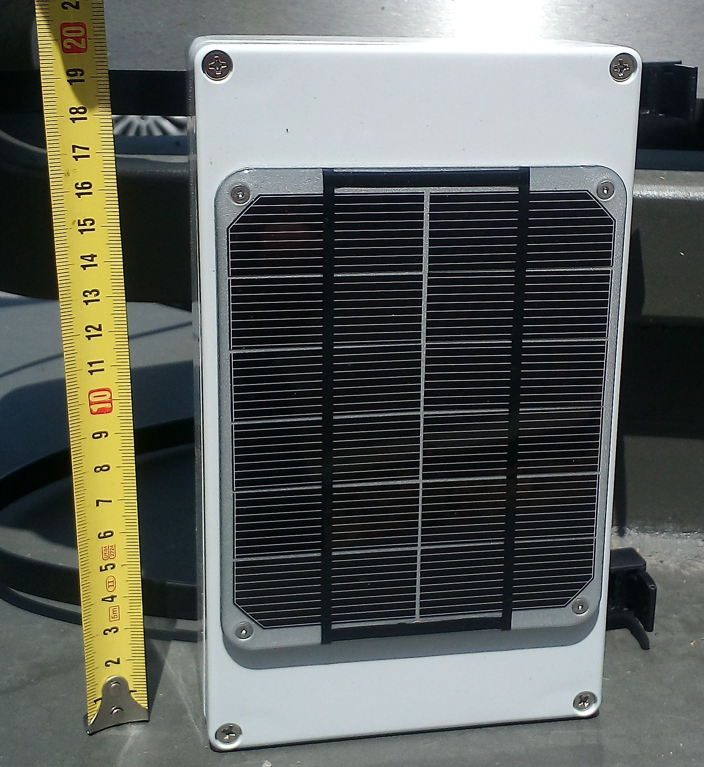
Figure 1. Sensor case - containing the PCB, the shock sensor, the battery and the PV panel installed on the surface of the case.
The data is then forwarded via Long Range Wide Area Network (LoRaWAN) connection standard to a mobile gateway. A single gateway supports several devices (up to 30), depending on the gateway model. The maximum distance at which communication between a device and the gateway is guaranteed is up to 2-3 km. The sensor reports wakeup measurements every 12 hours (this can be adjusted before installation) as a sign of functionality or to assess the status of the network. In case of an impact larger than the preset threshold, the sensor records a configurable number of measurements and sends the data immediately.

Test site in Slovenia

Due to the increasing frequency of rockfall events in the Slovenian state road network, the Slovenian Agency for Infrastructure, in cooperation with DRI Ltd, established a new project for preventive road protection measures against rockfall. Approximately 16,500 metres of flexible rockfall barriers and other protective measures were installed in recent years. As a result, many activities are now focused on establishing a regular maintenance schedule for these protective measures This primarily aims to streamline on-site inspection time, reduce costs, and in the simultaneously define the current state of the barriers.

In October 2021, five sensors were installed on a 100-meter-long rockfall barrier with an energy level of 2000 kJ above the state road in the eastern part of Slovenia (see Figure 2). Over the course of two years, data regarding the number of rockfall events, their locations, and the intensity of rock impacts were collected.

It is anticipated that the various types of data provided by these sensors will enable the development of algorithms for predictive maintenance. This advancement will facilitate the establishment of a consistent, long-term preventive maintenance plan. This marks the initial step towards optimizing future maintenance efforts and reducing associated costs.

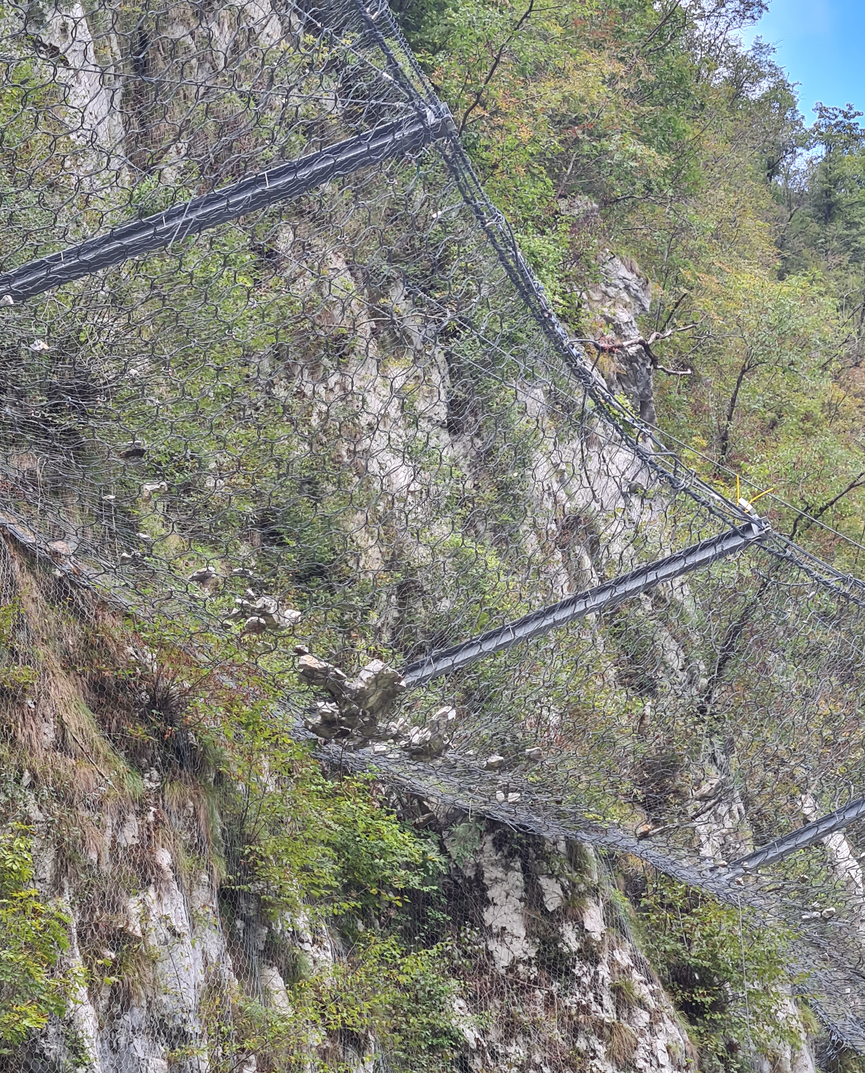
Figure 2. Test site in Slovenia and sensors installation

Data visualisation and usability

After a measurement is completed, the data is sent to a server via the gateway and stored in a database.

Data description: The data is specified with a three-dimensional acceleration vector (x,y,z). The frequency of the measurement is ...

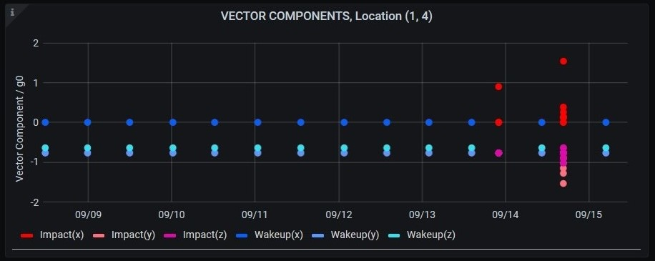
Figure 2.

The database is then visualized via Grafana, a multiplatform monitoring tool with web interface visualization (Quelle) All locations and sensors are accessible here and anyone with authorization can view the data or make their own visualizations (Grafana dashboard). The data are used to determine the number of events or the location and intensity of an impact. In addition, Grafana generates automatic alarm SMS/Email for different thresholds using the database analysis. Herewith the customer is informed immediately about significant events.

Discussion

The focus of this study was primarily on the development of a user-friendly architecture for the sensor network. Hence, the data are presented in a purely qualitative evaluation. We emphasize that only minor rockfall events were detected during the two-year measurement period. Consequently, no data of a major impact could be collected, which would require a complete replacement of the safety net. In addition, disturbance signals with a strength of up to 2g could be attributed to strong storms and corresponding winds or hail. To filter these interfering signals, a comparison with data from another sensor would be essential. However, this is foreseen in a follow-up project in cooperation with Trumer GmBh, Almosys and the ÖBB for the next two years. The core of the project is to develop and test a novel structure-borne sound sensor and to compare it with the shock sensor presented here.

Conclusion

A major advantage of the presented architecture is that other sensor technologies can be easily integrated into the network to provide redundancy or to capture other parameters of the rockfall process. In the near future, we aim to expand the network to integrate a novel structure-borne sound sensor.

References

Ragnoli, M. et al. (2023) ‘Wireless Sensor Network-Based Rockfall and Landslide Monitoring Systems: A Review’, Sensors, 23(16), p. 7278. Available at: https://doi.org/10.3390/s23167278.
Scavia, C. et al. (2020) ‘Evaluating Rockfall Risk: Some Critical Aspects’, Geosciences, 10, p. 98. Available at: https://doi.org/10.3390/geosciences10030098.
Segalini, A. et al. (2023) ‘Impact identification on flexible rockfall barriers: on site test of a wireless monitoring system’, IOP Conference Series: Earth and Environmental Science, 1124(1), p. 012125. Available at: https://doi.org/10.1088/1755-1315/1124/1/012125.
Yan, Y. et al. (2019) ‘Monitoring and early warning method for a rockfall along railways based on vibration signal characteristics’, Scientific Reports, 9(1), p. 6606. Available at: https://doi.org/10.1038/s41598-019-43146-1.

